SSM Session Manager
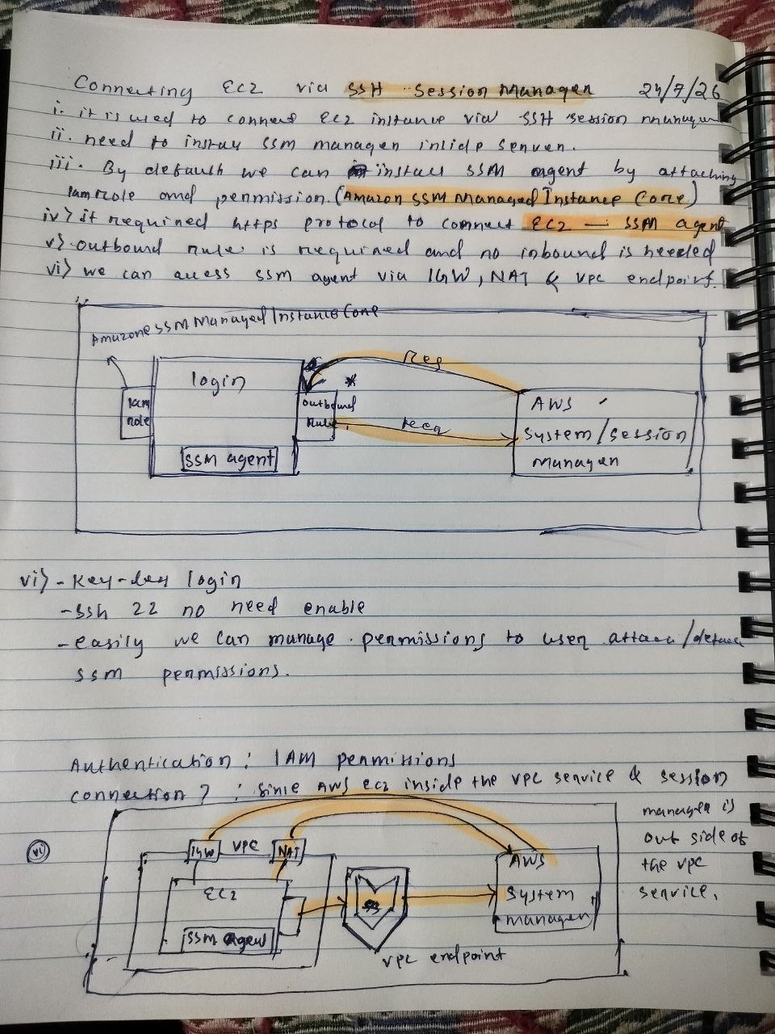
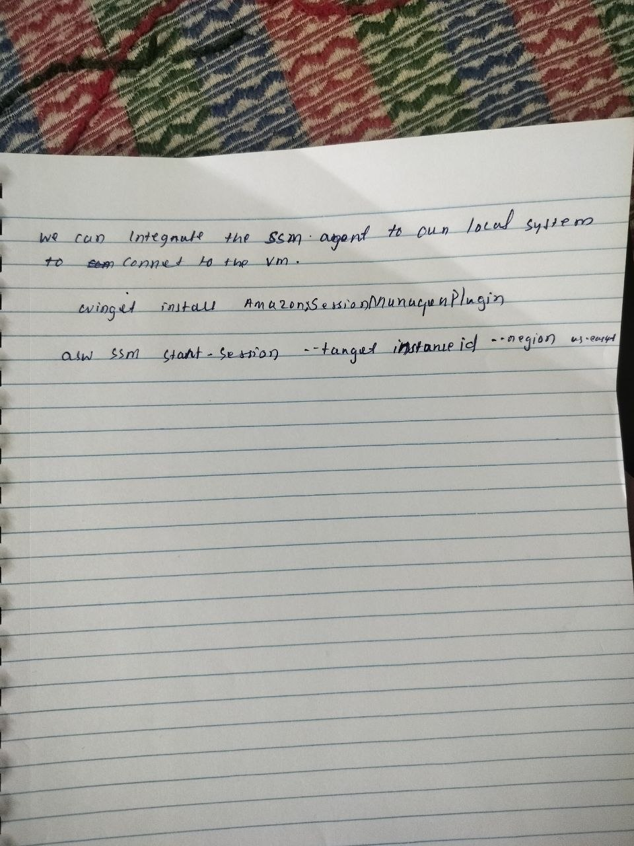

Connecting EC2 via AWS Systems Manager (SSM) Session Manager
Date: 24/07/2026

What is AWS Session Manager?
AWS Systems Manager Session Manager allows you to securely connect to your EC2 instances without using SSH keys or opening port 22.
Instead of SSH, the EC2 instance communicates with the AWS Systems Manager service over HTTPS (port 443).

Prerequisites

1. Install SSM Agent
The EC2 instance must have the SSM Agent installed.
Most modern Amazon Linux, Ubuntu, and Windows AMIs already include the SSM Agent.

2. Attach IAM Role
Attach an IAM Role to the EC2 instance with the following managed policy:
AmazonSSMManagedInstanceCore
This policy allows the EC2 instance to register itself with Systems Manager.

3. Network Requirements
The EC2 instance must be able to reach AWS Systems Manager endpoints using HTTPS (Port 443).
There are three ways:
- Internet Gateway (IGW)
- NAT Gateway
- VPC Interface Endpoints (PrivateLink)
No inbound connectivity is required.

How Session Manager Works
+-------------------------+
| Local Machine |
| AWS Console / AWS CLI |
+-----------+-------------+
|
|
v
+-------------------------+
| AWS Systems Manager |
+-----------+-------------+
^
|
HTTPS (443)
|
+-----------+-------------+
| EC2 Instance |
| SSM Agent Running |
+-------------------------+
The connection is initiated by the SSM Agent, not by your laptop.

Advantages over SSH

No SSH Keys
No need to create or manage
- PEM files
- SSH Keys

No Port 22
You don't need to open:
TCP 22
This significantly improves security.

IAM Authentication
Access is controlled using IAM Policies.
Example:
User A → Allowed

User B → Denied
No need to distribute private keys.

